ROUGH DRAFT

Title:

Propensity-weighted prognostic associations of hypercapnia by Arterial and Venous Blood Gas: A retrospective, multicenter health records study

Authors:

Anila Mehta MD¹, Jeanette P. Brown MD, PhD², Ramkiran Gouripeddi MBBS MSc³, Ithan Peltan⁴, Brian W. Locke MD, MSc⁴

¹University of Utah Internal Medicine Residency
² Division of Pulmonary, Critical Care, and Occupational Pulmonary Medicine, University of Utah
³Department of Biomedical Informatics, University of Utah
⁴Department of Pulmonary and Critical Care, Intermountain Medical Center.

Conflicts of Interest:

Author Contributions:

Data/Code Availability Statements:

Abstract:

Background:

Methods:

Results:

Conclusions:

Introduction:

Arterial blood gases (ABGs) are considered the gold standard for assessing acid-base balance, oxygenation and ventilation status, and remain essential in the management of hypercapnic respiratory failure. However, obtaining an ABG can be uncomfortable for patients, time-consuming and technically challenging, often requiring multiple attempts. Potential complications from ABGs include arterial injury, thrombosis, air or clotted blood embolism, arterial occlusion, hematoma, and aneurysm formation. ¹

Given these challenges with ABGs, clinicians have increasingly looked to venous blood gases (VBGs) as an alternative. Hypercapnia results from lungs’ inability to adequately remove carbon dioxide from the bloodstream, leading to its accumulation. On ABG, hypercapnia is defined as greater than 45 mmHg while on VBG, hypercapnia is usually defined as greater than 50 mmHg. VBGs are increasingly being used as a screening tool for hypercapnia due to ease of collection and reduced risk, though they are less precise in measuring arterial pCO₂ compared with ABGs.
Despite their growing use, there has been limited studies comparing VBG versus ABG in diagnosis of hypercapnic respiratory failure, and billing and device qualification guidance does not admit venous blood gas as sufficient evidence of hypercapnic respiratory failure. In a study by Davies et. al, hospitalized patients with known or suspected hypercapnic respiratory failure underwent near-simultaneous ABG and VBG testing. Results demonstrated close agreement in PaCO₂ values between ABG and calculated values derived from VBGs, supporting the use of VBGs in monitoring hypercapnic patients.² Similarly, a review by Lacy et. al analyzed a prospective study which found VBG to have 100% sensitivity in identifying hypercapnia in those with respiratory failure due to COPD exacerbation, pneumonia, heart failure and asthma using PvCO₂ greater than 45 mmHg.¹ Ak et. al published an additional prospective study in COPD patients in acute exacerbation that found VBG to identify hypercapnia in 100%. ³ In contrast, McKeever found wide variability between arterial and venous CO₂ levels in COPD patients with acute exacerbations, underscoring the limitations of VBG precision.⁴ Most prior studies have emphasized the analytical agreement between venous and arterial blood gases. Few have examined whether hypercapnia identified by each method carries similar prognostic weight, or whether observed differences reflect patient selection rather than biology. If venous hypercapnia predicts outcomes adverse outcomes such as the need for ventilatory support, this would support using VBGs as diagnostic evidence of hypercapnic respiratory failure.
Comparisons between ABG and VBG have often emphasized measurement agreement or categorical concordance. While such analyses are important to assess interchangeability, they assess only the analytic dimension of validity. Clinical utility, however, ultimately depends on prognostic relevance – how well each measure aligns with patient-centered outcomes. Analytic discordance alone does not indicate inferiority if prognostic performance is preserved. Our study focused on evaluating prognostic associations rather than measurement agreement alone.
The objective of this study was to determine the associations of hypercapnia by ABG and VBG with hypercapnia-related outcomes, such as receipt of a diagnosis code for hypercapnic respiratory failure, receipt of invasive mechanical ventilation, receipt of non-invasive ventilation (NIV), and 60-day any-cause mortality, after adjusting for propensity to receive each type of blood gas sampling. We hypothesized that venous and arterial measures of hypercapnia would demonstrate similar associations with clinical outcomes, supporting the functional utility of VBGs as a prognostic alternative to ABGs.

Methods:

This multicenter retrospective cohort study using de-identified patent data from the 2022 TriNetX research network (TriNetX, LLC. Cambridge, MA), which aggregates electronic health record data from participating health systems. Which provides deidentified individual-level patient data from 76 medical centers across the US serving roughly 115 million patients at the time of data requisition. The University of Utah Institutional Review Board reviewed the study protocol and determined the project met criteria for exemption (IRB #00184622).

Study Population

Patients were eligible for inclusion if they had at least one reason indicating a reasonable suspicion might suspect hypercapnia (see e-appendix 4 figure) during emergency or inpatient encounter from Jan 1 to Dec 31 2022. Ambulatory encounters were excluded from the dataset.
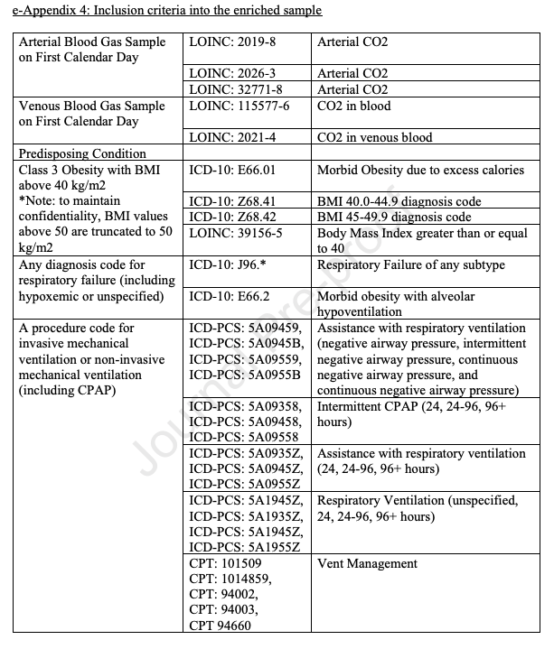

Patients with missing key demographic or outcome data were excluded.

Exposure

Arterial and Venous blood gas samples from the calendar day of the encounter start were included.

The following LOINC codes were used to identify arterial (LOINC: 2019-8, LOINC: 2026-3, LOINC: 32771-8 ) and venous (LOINC: 115577-6, LOINC: 2021-4) blood gasses.

CO₂ was represented in two ways. First, as a categorical variable: low (PaCO₂ < , PvCO₂ < ), normal (– mmHg), and high (PaCO₂ ≥ 45 mmHg, PvCO₂ ≥ 50 mmHg). Second, as a continuous variable using a restricted cubic spline with *** knots, allowing flexible non-linear shapes such as bends or curves.

Outcomes
The four outcomes analyzed included hypercapnic respiratory failure diagnosis code: ICD-10-CM codes E66.2, J96.02, J96.12, J96.22, and J96.92, r
eceipt of non-invasive ventilation procedure code at any time during the hospitalization, r
eceipt of an invasive mechanical ventilation procedure code at any time during the hospitalization and
all-cause mortality within 60 days of encounter start. The 60-day window was selected based on ARDS literature, where this time point captures the greatest intervention-related mortality differences, reflecting the period when deaths attributable to respiratory failure and its management are most apparent.
Statistical Modeling
Separate simple logistic regression models were fit to evaluate the association between pCO₂ category (below normal, normal, above normal) and each of the four outcomes listed above and no adjustment for additional variables. Odds ratios (Ors) with 95% confidence intervals (Cis) were calculated, using the normal pCO₂ group as the reference. Odds ratios from categorical models were displayed using forest plots on a logarithmic scale, stratified by cohort. An additional set of four simple logistic regression models were fit using restricted cubic splines. Conditional predicted probabilities of each outcome were estimated across the full observed range of pCO₂ values, with 95% confidence intervals.
To address differences in the types of patients who receive arterial versus venous blood gas sampling, we applied inverse probability of selection weights (IPSWs). This approach estimates each patient’s likelihood of receiving a blood gas based on observed covariates. Patients who were unlikely to be tested but nonetheless had a blood gas drawn are up-weighted, representing similar patients in the population who were not sampled. Separate models were created to model propensity to receive ABG testing and propensity to receive VBG testing. Patients who received ABG testing were then re-weighted by the ABG propensity to approximate the target population of patients with any reason to suspect hypercapnia. Patients who underwent VBG testing were then reweighted to the same population. The resulting reweighted samples to the same target populations allows for comparisons of prognostic significance while adjusting for differences in the types of patients sampled.
Propensity scores were estimated by modeling the likelihood of obtaining an arterial or venous blood gas, belonging to each cohort based on encounter type (emergency or inpatient), demographic variables (age, sex, race, ethnicity, BMI, location), comorbid conditions diagnosed on or before the index encounter (COPD, asthma, OSA, CHF, neuromuscular disorders, pulmonary hypertension, CKD, diabetes) and other objective data including triage vital signs and basic initial labs. Propensities were estimated using extreme gradient boosting machines (XGBoost; *** parameter settings), a machine learning algorithm that natively handles non-linearities and missing data. Weights were windsorized (truncated) at the 1st percentiles to avoid unstable weights and patients who may have had no realistic chance of receiving blood gas sampling. Covariate balance was evaluated using standardized mean differences, with <0.1 indicating acceptable balance. Additionally, propensity score distributions were compared graphically to assess overlap between groups before and after weighting.
Model interpretability was evaluated using both global feature importance and SHAP (Shapley additive explanations) analyses. Global feature importance, derived from the gradient boosted model’s relative influence scores, quantified each covariate’s overall contribution to model performance across the training distribution. To complement this, SHAP values were computed to provide local, signed attributions for each individual, indicating how much each feature increased or decreased the log-odds of receiving an ABG or VBG relative to the model baseline. Global SHAP summaries, calculated as the mean absolute SHAP value across all observations, captured the typical magnitude of each feature’s effect on predictions and allowed directional interpretation of feature influence.
Software: R version ***, using packages rms, weightit ***
Code is available at ***

Results:

A total of *** patients met inclusion criteria for the study, see figure CONSORT. Patients were categorized according to blood gas type and the presence or absence of hypercapnia, resulting in six analytic groups. Baseline demographic and clinical characteristics for these groups are summarized in Table 1 and 2.

***Add description of Table 1 and 2***

Table 1: Baseline Characteristics including demographics, comorbidities and pCO₂ grouped by all patients and then divided among four groups depending on the blood gas received or not received.

Table 2: Baseline Characteristics including demographics, comorbidities and pCO₂ grouped by which blood gas received (ABG versus VBG) and whether hypercapnia was present.

Figure 1 displays the adjusted odds ratios with 95% confidence intervals, comparing below-normal and above-normal pCO₂ groups to the normal reference group for invasive mechanical ventilation, noninvasive ventilation, 60-day mortality, and diagnosis of hypercapnic respiratory failure. The below-normal pCO₂ groups demonstrated odds ratio close to 1.0 for non-invasive ventilation and hypercapnic respiratory failure, suggesting little difference compared with the normal pCO₂ group. In contrast, patients in the above-normal pCO₂ groups had substantially higher odds of receiving non-invasive ventilation and being diagnosed with hypercapnic respiratory failure. Across the four outcomes, the above-normal pCO₂ for ABG and VBG were consistent and not statistically significant.

Figure 1: Inverse Propensity Weighted Odds Ratio of Outcomes by pCO₂ Category (below normal pCO₂ and above normal pCO₂). The above normal pCO₂ groups have much higher likelihood of receiving noninvasive ventilation and diagnosis of hypercapnic respiratory failure compared to the below normal pCO₂ group.

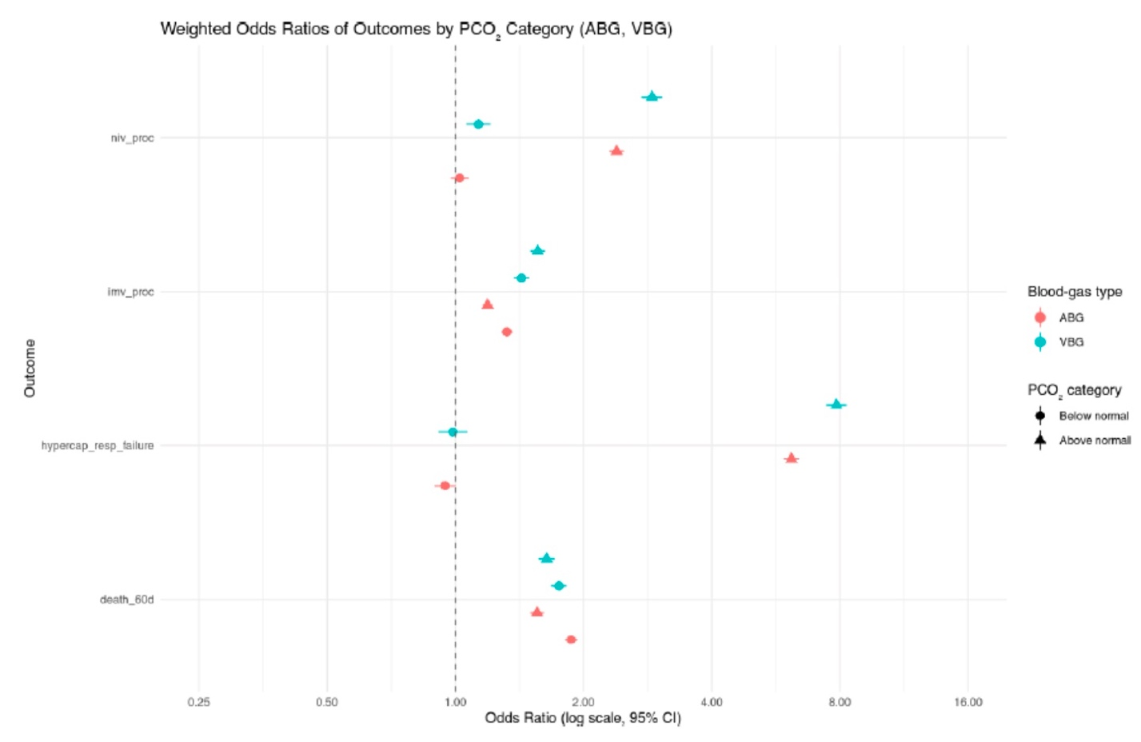

To further examine the continuous relationship between pCO₂ and clinical outcomes, restricted cubic spline models were constructed. Figure 2 presents the predicted probabilities for each outcome across pCO₂ values, stratified by ABG and VBG groups.

In Figure 2, there is a significant higher likelihood of receiving the four outcomes for the VBG group compared to ABG group as pCO₂ levels increase. Hypercapnic respiratory failure diagnosis and non-invasive ventilation had the largest gap in likelihood between the two groups. The predicted probability of the outcomes begin to increase at about 45 mmHg for ABG and 50 mmHg for VBG. Finally, mortality appeared unrelated to CO₂ status for the ABG group, suggesting that death in this cohort is more reflective of overall illness severity rather than hypercapnia itself.

Figure 2: Inverse Propensity Weighted Predicted Probability by ABG and VBG for the four outcomes. VBG group had higher likelihood of receiving the four outcomes compared to ABG group as pCO₂ levels increase. The gap was most significant for the hypercapnic respiratory failure diagnosis and non-invasive ventilation.

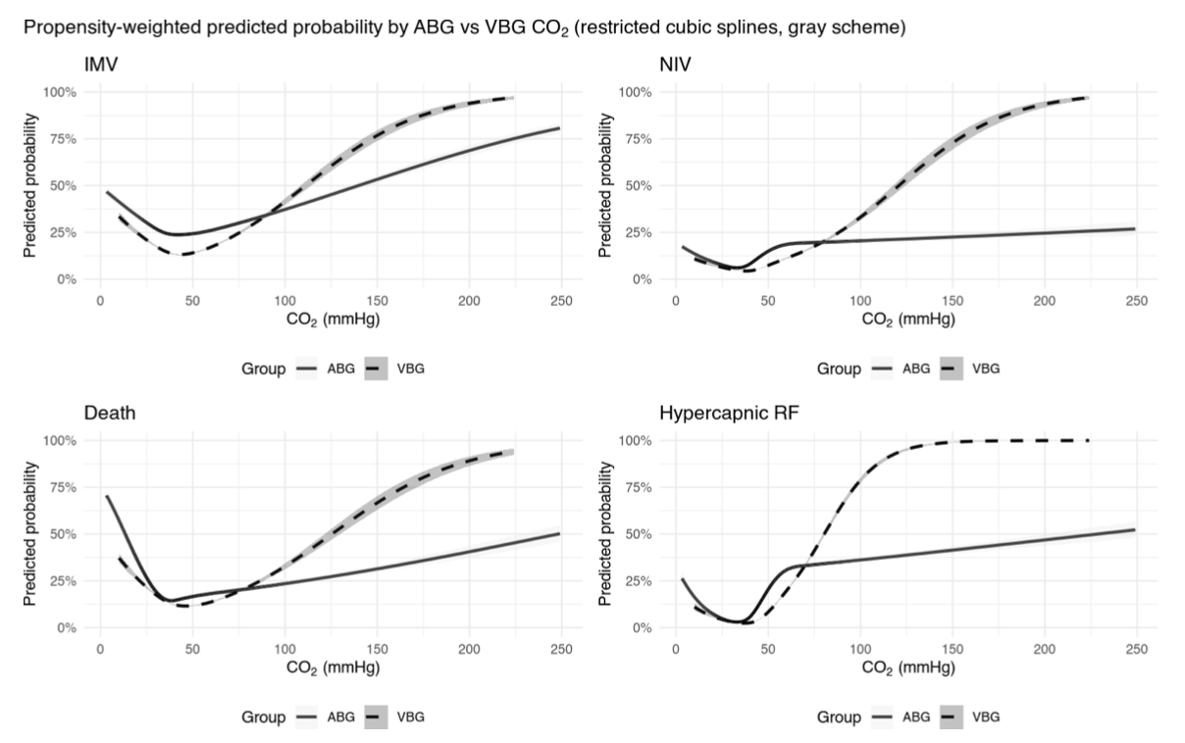

Discussion:

Overall, these findings suggest that venous and arterial blood gas measurements provide comparable clinical information in predicting key outcomes, including non-invasive ventilation, invasive mechanical ventilation, diagnosis of hypercapnic respiratory failure and 60-day mortality. The absence of significant differences between VBG and ABG groups indicate that VBG testing may be sufficient for guiding management decisions in many patients, potentially reducing the need for more invasive arterial sampling.

Previous studies have shown that venous and arterial pCO₂ values are strongly correlated. However, the prior work has focused on diagnostic accuracy or correlation coefficients rather than clinical outcomes. Our study expands upon the current literature by linking arterial and venous blood gas measurements to meaningful clinical outcomes such as mechanical ventilation and mortality. Our results have broader implications for both clinical practice and healthy system policy. Despite widespread clinical use of VBGs to assess hypercapnia, formal diagnostic criteria, billing structures and device qualification requirements still rely on arterial confirmation. Aligning these frameworks with real-world practice could simplify workflows, reduce patient discomfort, and lower costs without comprising diagnostic accuracy. Expanding the acceptance of venous-based definitions may also enable more efficient outpatient follow-up and titration of non-invasive ventilation or supplemental oxygen therapy.

mortality.

Strength and Limitations

This study has several strengths. Its large, multi-institutional cohort enhances analytic flexibility and minimizes overfitting risk, allowing stable modeling of sampling and outcome relationships. The study design reflects real-world clinical practice by stratifying patients who underwent either ABG or VBG testing, providing insight into how hypercapnia is assessed and managed across different clinical contexts. The use of multivariable logistic regressions and inverse propensity weighting allowed for the adjustment of measured cofounders and provided a robust assessment of associations between hypercapnia and important clinical outcomes such as mechanical ventilation, non-invasive ventilation and 60-day mortality. Propensity scores were estimated using a machine learning method that accommodates non-linear relationships and missing data.

However, this study does have certain limitations. The retrospective design of this study eliminates casual inference and is at risk for confounders that bias results. Unmeasured variables such as provider practice style or illness severity may have influenced both the likelihood of testing and clinical outcomes. Since data was extracted from the electronic health record, misclassification or missing data in comorbidities, test results or outcomes is possible. This study relied on single blood gas measurements obtained on hospital day 1, which limits the ability of assess temporal changes in pCO₂ or the effect of repeated sampling over time.

Further work is needed to confirm these findings in prospective studies. Pragmatic prospective cohort with protocolized testing omparing ABG versus VBG management could more directly establish causality and inform guidelines. Repeated measurements throughout a patient encounter as well would also better capture the relationship between changing pCO₂ values and outcomes. Additionally, subgroup analyses focusing on specific patient populations with certain comorbidities will further clarify whether VBGs are equally reliable as ABGs.

Conclusion:

In reweighted cohorts, VBG-identified hypercapnia showed similar prognostic associations to ABG for ventilatory support and mortality. VBG results were also similarly associated with subsequent diagnostic labeling, suggesting its use despite current formal criteria. Broader acceptance of VBG-based definitions in billing and device qualification should be considered, pending external validation and associations with post-discharge management.

References:

1. Lacy ME, Saa L, Bruss Z, Noronha L. Things We Do for No ReasonTM: Arterial blood gas testing to screen for hypercarbic respiratory failure. J Hosp Med. 2025;20(9):1002-1004. doi:10.1002/jhm.70039
2. Davies MG, Wozniak DR, Quinnell TG, et al. Comparison of mathematically arterialised venous blood gas sampling with arterial, capillary, and venous sampling in adult patients with hypercapnic respiratory failure: a single-centre longitudinal cohort study. BMJ Open Respir Res. 2023;10(1):e001537. doi:10.1136/bmjresp-2022-001537
3. Ak A, Ogun CO, Bayir A, Kayis SA, Koylu R. Prediction of Arterial Blood Gas Values from Venous Blood Gas Values in Patients with Acute Exacerbation of Chronic Obstructive Pulmonary Disease. Tohoku J Exp Med. 2006;210(4):285-290. doi:10.1620/tjem.210.285
4. McKeever TM, Hearson G, Housley G, et al. Using venous blood gas analysis in the assessment of COPD exacerbations: a prospective cohort study. Thorax. 2016;71(3):210. doi:10.1136/thoraxjnl-2015-207573

Supplement:

Things like the propensity diagnostics could be included in the supplement.

Figure S1: Distribution of Inverse Propensity-Weighted Scores for ABG and VBG groups. Untested patients clustered near zero, while tested patients were skewed toward higher probabilities of being tested.

